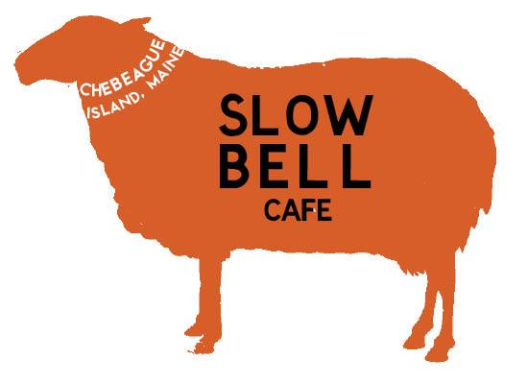
Columbus Day Weekend
Open Fri, Sat, & Sun 5-9 for Dinner
Bar open until MIDNIGHT
Friday: Karaoke 9-11
Saturday: The WESTENDERS (Mark and Chuck) 8-11
Sunday: OPEN MIC w/Mark Bowman 8-11
We will have wings, fries, pizza by the slice, and nachos while the bar is open all weekend long. Our dinner specials include: pot roast, haddock chowder, lobster tacos and beer battered lobster.

